Contemporaneous Notes

Examiner | Alish Mahat (23000965) | Exam commenced | 13/12/2023
Other relevant information | Any relevant information? | Software used, versions and licensing | Autopsy 4.20.0  RegRipper 3.0  AccessData® FTK® Imager 4.7.1.2
Note: If you decide to omit a process, then you should provide your reasons for doing so. You may add additional rows, as appropriate.

Action | Done? | Date | Time | Notes
Load case and verify image | Yes | 13/12/2023 | 7.45am | - Open Autopsy and initiate a new case by selecting "New Case." Choose a directory for storing the case file.  - Opt for "Disk image" as the data source type.  - Specify the path to the Hunter image file as the data source. Set the time zone to (GMT +00) UTC.  - Execute all ingest modules, covering files, directories, and unallocated space, to comprehensively process and verify data source integrity.  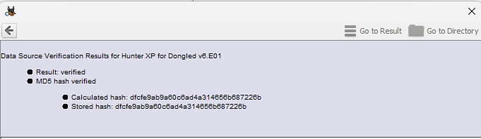
Load Case into second forensic tool for dual verification of at least 2 key artefacts, evidence items | Yes | 13/12/2023 | 8.00am | - Installed FTK Imager for image processing.  - Processed the same image used in Autopsy.  - Checked hex values using FTK Imager.  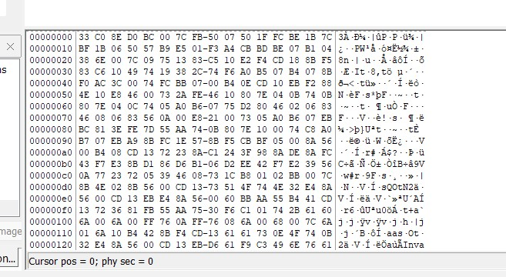  - Compared the hex values obtained in FTK Imager with those in Autopsy for verification.  - Utilized FTK Imager to examine the NTUSER.DAT file.  - Extracted relevant information from the NTUSER.DAT file using FTK Imager.  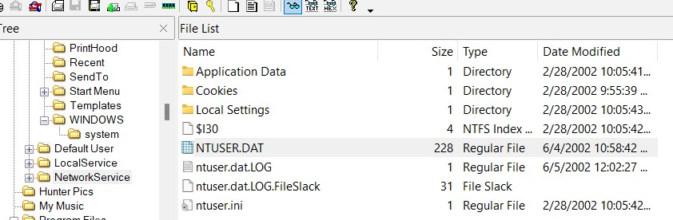
Time Zone Adjusted?  Report Time Zone used for Analysis. | Yes | 13/12/2023 | 8.01am | - Navigate to "Tools" in the menu.  - Select "Options."  - Under the "View" tab, choose "Use another time zone."  - Set the time zone to "(GMT+0:00) GMT."  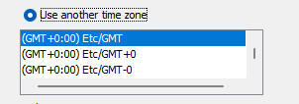
Recover lost folders  (NTFS, FAT16&32). | Yes | 13/12/2023 | 8.05am | - Identified deleted files in the file system.  - Successfully recovered possible deleted files.  - Saved the recovered folders in "Carved Files."  - Accessed the recovered files through "File Views > Deleted Files > File System."  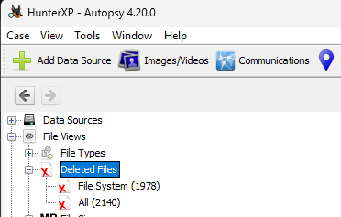
Mount archives;  zip, thumbs.db, etc. | Yes | 14/12/2023 | 7.00am | - Discovered zip folders within the archives section.  - Accessed them through "File Views > File Types > By Extension > Archives."  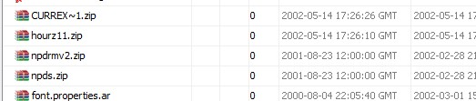  - Located the "thumbs.db" folder within the "Hunter Pics" folder in the CD Burning section.  - Identified subfolders within "Hunter Pics" containing pictures of Sabrina and Christina.  - Traced the path through "Data Sources > Hunter XP for Dongled v6.E01_Host > Hunter XP for Dongled v6.E01 > vol2 > Documents and Settings > Bob Hunter > Local Settings > Application Data > Microsoft > CD Burning > Hunter Pics > Thumbs.db."
File signature analysis (any interesting file mismatch?);  Compute hash values (enable entropy computation) | Yes | 14/12/2023 | 8.25am | - Discovered discrepancies in file types where content differed from the indicated extension.  - Found image data within some .tmp files and information about Root Entry in certain MS Office files.  - Identified a total of 58 files with extension mismatches.  - Accessed the findings under "Analysis Results > Extension Mismatched."  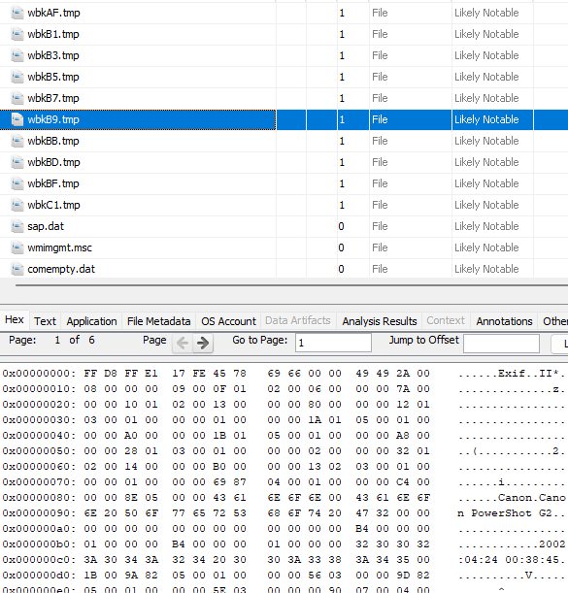
Internet History, favourites, etc.  Other browsers? | Yes | 15/12/2023 | 9.30am | - Observed various websites visited by Bob Hunter, including google.com, yahoo.com, jetico.com, aol.com, and search.com.  - Noted that all URLs were accessed exclusively through Internet Explorer.  - Discovered 16 bookmarked webpages.  - Accessed this information under "Data Artifacts > Web History."  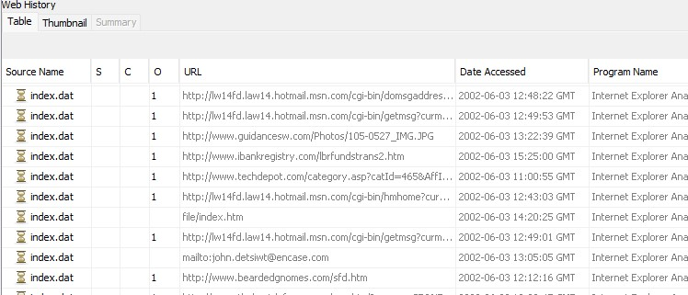  - Identified links and media added to the favorites by the user.  - Located this data in the path: "vol2 > Documents and Settings > Bob Hunter > Favourites."  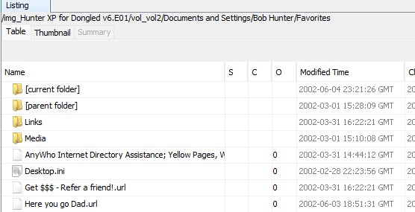  - Located IE cache with anti-forensics tools at:  - Path: "/vol_vol2/Documents and Settings/Bob Hunter/Local Settings/Temporary Internet Files/Content.IE5/8XGPQD6L/bcrypt7[2].htm"  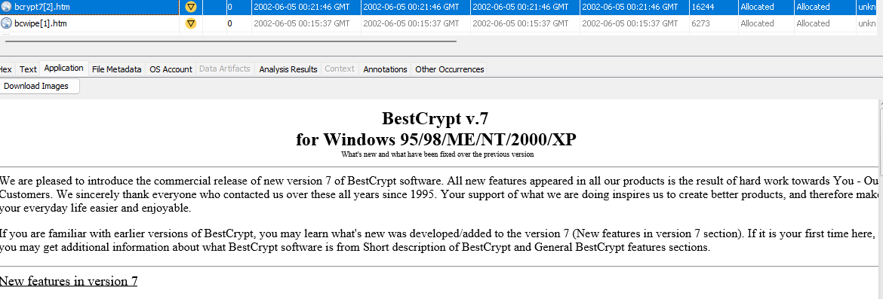  - Path: "/vol_vol2/Documents and Settings/Bob Hunter/Local Settings/Temporary Internet Files/Content.IE5/8XGPQD6L/bcwipe[1].htm"  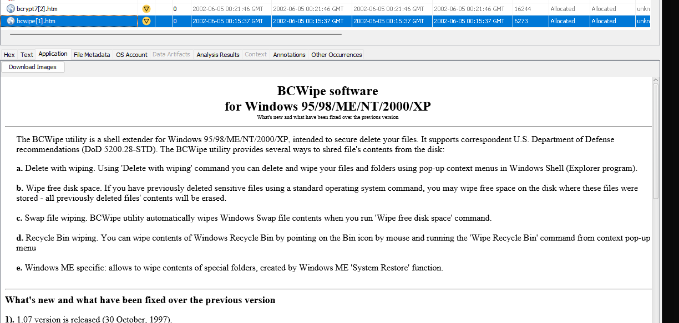  - Internet Explorer Favorite:  - Path: "/vol_vol2/Documents and Settings/Bob Hunter /Favorites/Here you go Dad.url"  - Points to: "http:/www.guidancesw.com/"  - Corresponding Cached File:  - Path: "/vol_vol2/Documents and Settings/Bob Hunter/Local Settings/Temporary Internet Files/Content.IE5/6ZSJ6T6D/guidancesw[1].htm"  - Contains content implying potential harm to the victim.  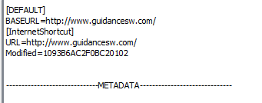  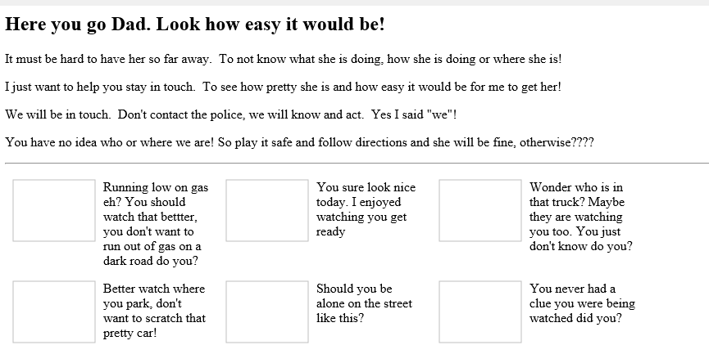
Emails, local and web-based. | Yes | 16/12/2023 | 7.00am | - Identified several email addresses that Bob Hunter has been contacted through.  - Located this information under "Analysis Results > Keyword Hits > Email Addresses."  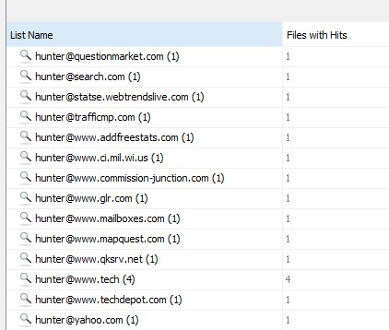  Located IE cache with mail exchange at:  - Path: "/vol_vol2/Documents and Settings/Bob Hunter/Local Settings/Temporary Internet Files/Content.IE5/042WFPGU/HoTMaiL[2].htm"  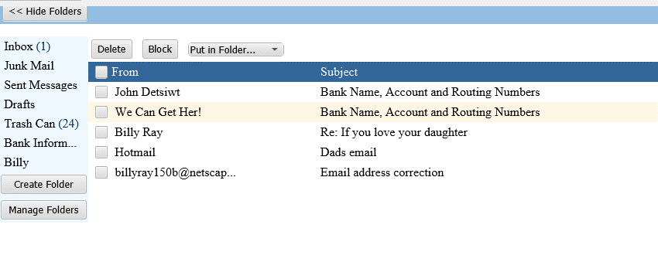
Retrieve operating system information, accounts information, software, time zone information etc.). | Yes | 16/12/2023 | 9.15am | - Extracted registry files SAM, SECURITY, software, and system from:  - Path: "vol_vol2/WINDOWS/system32/config"  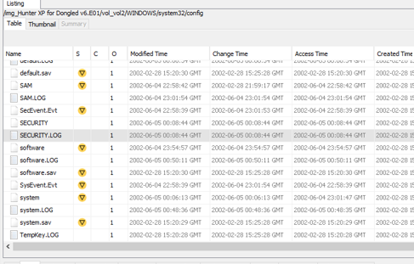  - Utilized RegRipper to extract information from the registry.  - Retrieved details such as OS information, accounts information, and time zone information from extracted file.  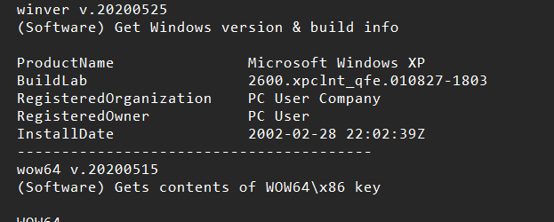  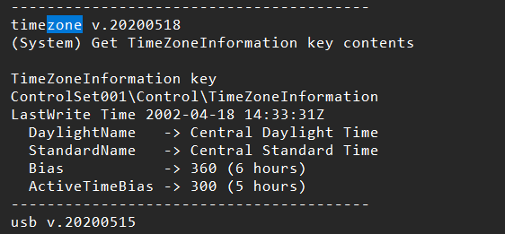  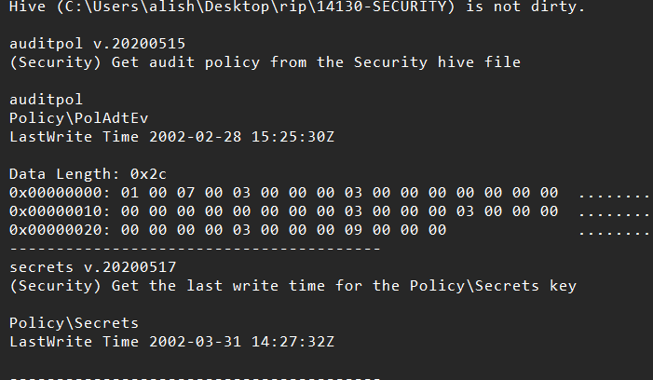  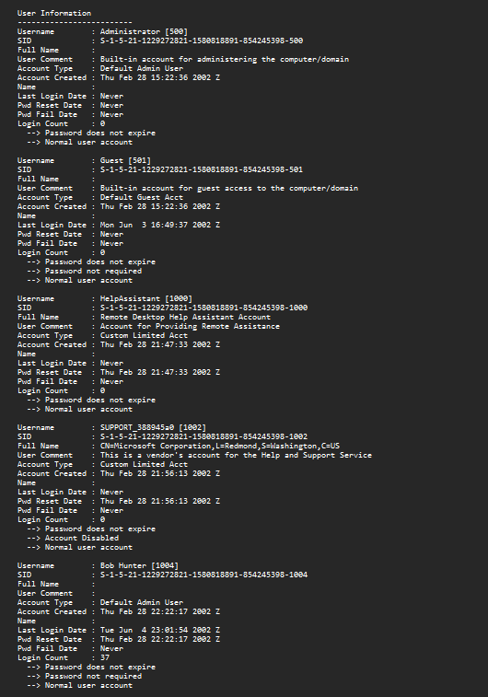
Timeline analysis-  Note date of last activity on the computer. System profiling. | Yes | 16/12/2023 | 10.00pm | - Last user activity involved the modification of the directory:  - Path: "/vol_vol2/Documents and Settings/Bob Hunter/My Documents/My Pictures/Hunter Pics/Christina Detsiwt/"  - Preceding this modification, there were activities including:  - Access of: "/vol_vol2/Documents and Settings/Bob Hunter/Local Settings/Application Data/Microsoft/CD Burning/Hunter Pics/Christina Detsiwt/Thumbs.db"  - CD-burning of images at the same directory.  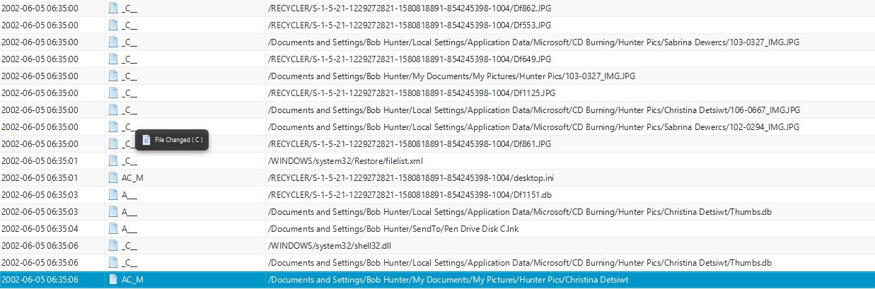
Registry analysis and  Registry protected area | Yes | 17/12/2023 | 7.00am | - Discovered and extracted registry hives (SAM, Security, System, and Software) from:  - Path: " /vol2/WINDOWS/system32/config"  - Utilized RegRipper to analyze the extracted registry hives.  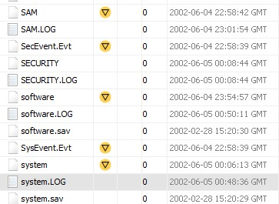  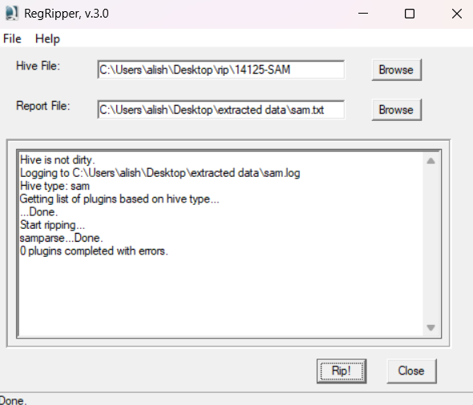
Link files and Recycle Bin | Yes | 17/12/2023 | 10.20am | - Discovered link files with the extension ".lnk" in the RECYCLER directory.  - Identified deleted files and folders stored in the RECYCLER directory.  - Path: “vol2 > RECYCLER," suggests a repository for deleted items on the system.  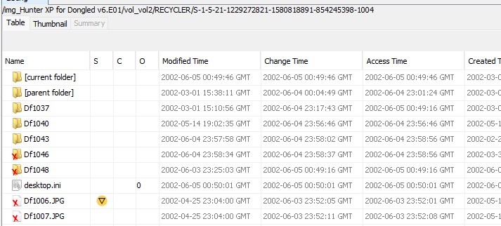
Instant Messaging clients | Yes | 17/12/2023 | 11.32am | - Yahoo Messenger and Instant Messenger were installed on the user's computer.  - Located this information in "Data Artifacts > Installed Programs."  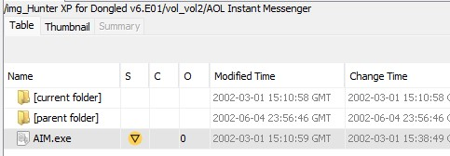  - Chaser1991 and billy ray 0001 discussing plans relevant to stalking of the victims and ransom  - Located this information under " vol_vol2/Program Files/America Online 7.0/download/Hunter.log."  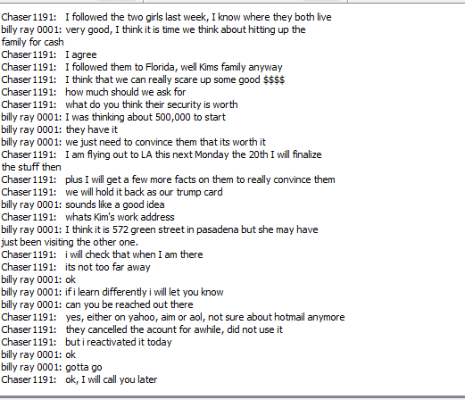  - Log with chase1991 discussing/querying anti-forensics tools, ie: secure disk wiping utility.  - Located this information under " vol_vol2/Program Files/America Online 7.0/download/Special Interests - Tech Chat.log "  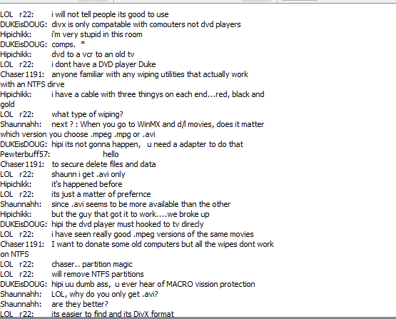
Clean-up/Wiping utilities. Check log files. Anything used? | Yes | 18/12/2023 | 7.00am | - Identified the execution of the clean-up tool "cleanmgr.exe" in the system.  - Located this information under "Data Artifacts > Run programs > CLEANMGR.EXE."  - Indicates evidence that the suspect researched disk wiping, with "bc wipe" found in temporary internet files.  - Located at: "/vol_vol2/Documents and Settings/Bob Hunter/Local Settings/Temporary Internet Files/Content.IE5/6ZSJ6T6D/Search[1].htm."  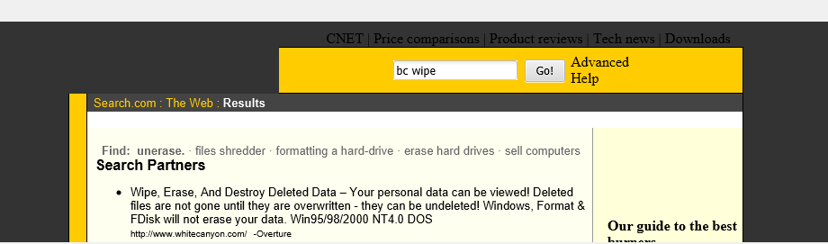
External drives; Network connections | Yes | 18/12/2023 | 10.10am | - Identified 11 USB devices that were connected to the PC.  - Located this information under "Data Artifacts > USB Device Attached."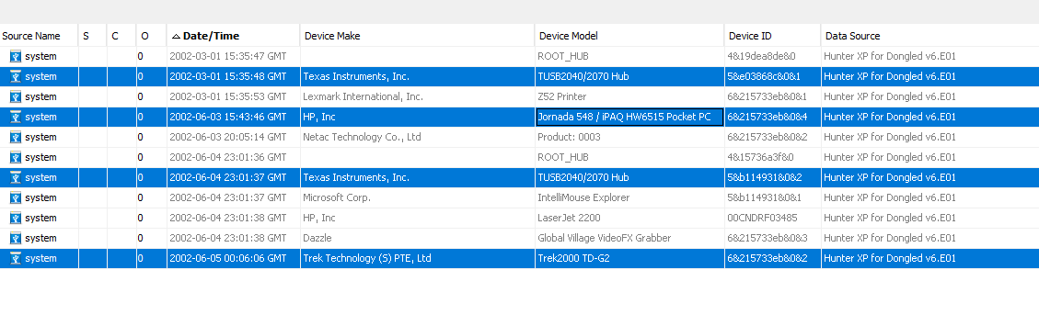  - Located information in "Documents and Settings > All Users / Application Data / Microsoft / Network /Connections / Pbk."  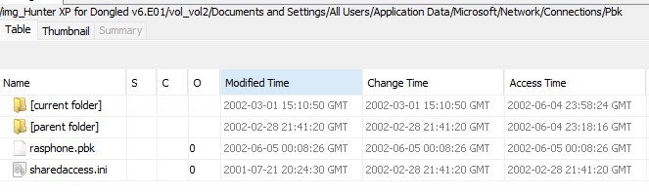  - Discovered a bookmarked link to an online drive service.  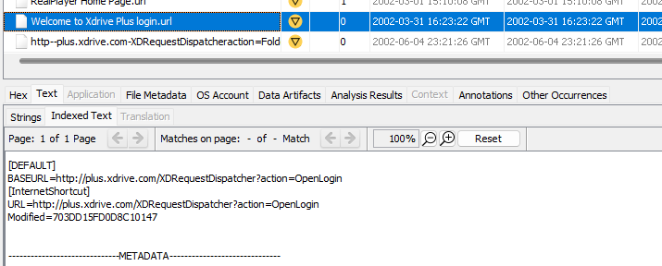
Perform data carving | Yes | 18/12/2023 | 7.30am | - Hidden and lost files were recoverd by file carving by Autopsy . Found those files stored in folder Carved Files  - Located information at ” > vol2 > CarvedFiles”  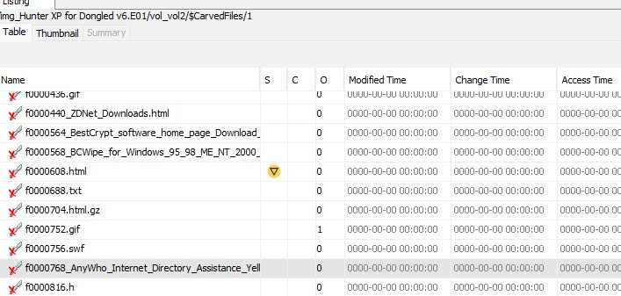
Run relevant keyword searches;  Did you index the evidence file? | Yes | 18/12/2023 | 11.45am | - Conducted several keyword searches during the case examination.  - Utilized the Keyword Search box for searching related files.  - Reviewed the results under "Analysis Results > Keyword Hits > Single Literal Keyword Search."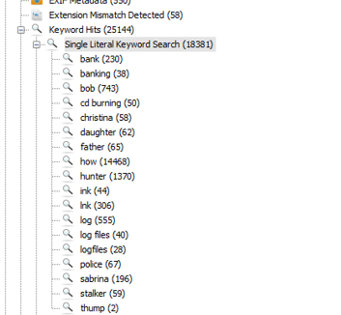
Recover Log-on passwords –  use SAMInside/Ophcrack/Encase | Yes | 19/12/2023 | 8.00am | - Extracted the SAM file from "/Img_Hunter XP for Dongled v6.E01/vol_vol2/WINDOWS/system32/config" in Autopsy.  - Used RegRipper to further extract information from the SAM file.  - Analyzed the extracted data and observed that no password is required.  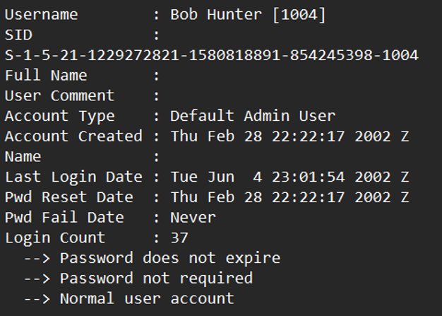
Examine different file types:  Export doc/office and exe files; look at Metadata if required | Yes | 20/12/2023 | 12.15pm | - Explored different file types based on extension and MIME type in File Views.  - Discovered various types such as PDF, TXT, and EXE.  - Accessed this information under "File Views > By Extension > Documents."  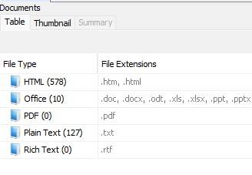  - Accessed this information under "File Views > By Extension > Executables."  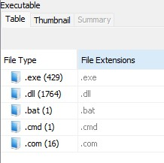
Encryption, Steganalysis (any indications? Entropy or Autopsy can be used) | Yes | 20/12/2023 | 12.30pm | - Suspected encryption in the file "oembios.bin" based on its high entropy.  - Located at: "/vol_vol2/WINDOWS/system32/oembios.bin."  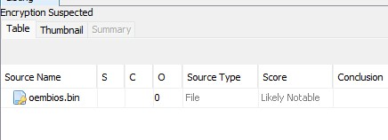
Print artefacts | Yes | 21/12/2023 | 7.50am | - Identified print spooler files in two different extensions: .shd and .spl.  - The Shadow file (.shd) contains information about the print job.  - Spool files (.spl) contain the RAW format of the printed content.  - Located these files at “vol2/WINDOWS/system32/PRINTERS."  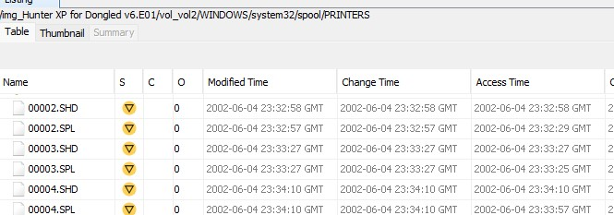  - Online drive registration: Located at "WINDOWS\system32\spool\PRINTERS\00011.SPL."  - Email sent to John Dewsit: Found in "WINDOWS\system32\spool\PRINTERS\00018.SPL."  - Secure wiping tool: Identified at "WINDOWS\system32\spool\PRINTERS\00020.SPL."  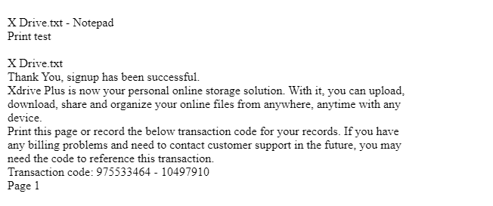  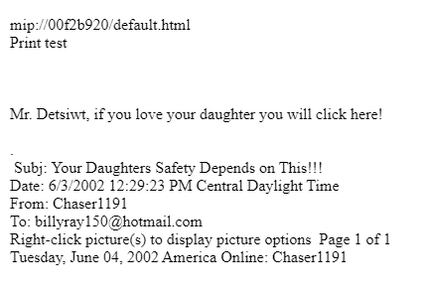
CD/DVD burning apps; check log files | Yes | 22/12/2023 | 7.10am | - CD burning was used to store pictures of the victims.  - Pictures of Christina and Sabrina were stored in the "Hunter Pics" folder on a CD.  - Location is "/vol_vol2/Documents and Settings/Bob Hunter/Local Settings/Application Data/Microsoft/CD Burning/Hunter Pics/."  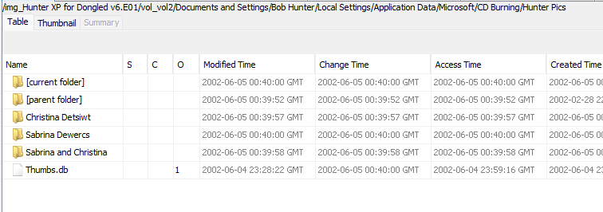
Validate evidence integrity at the end of the examination | Yes | 22/12/2023 | 10.30pm | - Hash values are consistent, indicating an examination conducted without data tampering.  - Ran the Ingest module to verify Data Source Integrity.  - Steps involved selecting "Tools" from the toolbar, running ingest modules for "Hunter XP for Dongled v6.E01," specifically targeting Data Source Integrity, and completing the process by selecting "Finish."  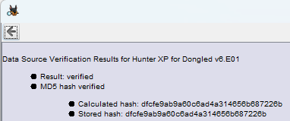

Additional Notes/Artefacts Examined:

Colour-coding Legend | Tasks
 | Fundamental
 | Basic
 | Elementary
 | Secondary
 | Advanced
 | Exceptional

